Lab 21 - ELK and Kibana

* Download and install Elasticsearch, Kibana, and Logstash from [https://www.elastic.co](https://www.elastic.co/).
* Update the Search microservice (chapter7.search). Review and ensure that there are some log statements in the Search microservice. The log statements are nothing special but simple log statements using slf4j, as follows:
* import org.slf4j.Logger;  
  import org.slf4j.LoggerFactory;  
   //other code goes here  
   private static final Logger logger = LoggerFactory.getLogger(SearchRestController.class);  
  //other code goes here  
     
  **logger.info("Looking to load flights...");**  
  for (Flight flight : flightRepository.findByOriginAndDestinationAndFlightDate("NYC", "SFO", "22-JAN-16")) {  
   **logger.info(flight.toString());**  
  }
* Add the logstash dependency to integrate logback to Logstash in the Search service's pom.xml file, as follows:
* <dependency>  
   <groupId>net.logstash.logback</groupId>  
   <artifactId>logstash-logback-encoder</artifactId>  
   <version>4.6</version>  
  </dependency>
* Also, downgrade the logback version to be compatible with Spring 1.3.5.RELEASE via the following line:
* <logback.version>1.1.6</logback.version>
* Override the default Logback configuration. This can be done by adding a new logback.xml file under src/main/resources, as follows:
* <?xml version="1.0" encoding="UTF-8"?>  
  <configuration>  
   <include resource="org/springframework/boot/logging/logback/defaults.xml"/>  
   <include resource="org/springframework/boot/logging/logback/console-appender.xml" />  
   <**appender name="stash" class="net.logstash.logback.appender.LogstashTcpSocketAppender">**  
   **<destination>localhost:4560</destination>**  
   **<!-- encoder is required -->**  
   **<encoder class="net.logstash.logback.encoder.LogstashEncoder" />**  
   **</appender>**  
   <root level="INFO">  
   <appender-ref ref="CONSOLE" />  
   <appender-ref ref="stash" />  
   </root>  
  </configuration>
* The preceding configuration overrides the default Logback configuration by adding a new TCP socket appender, which streams all the log messages to a Logstash service, which is listening on port 4560. It is important to add an encoder, as mentioned in the previous configuration.
* Create a configuration as shown in the following code and store it in a logstash.conf file. The location of this file is irrelevant as it will be passed as an argument when starting Logstash. This configuration will take input from the socket listening on 4560 and send the output to Elasticsearch running on 9200. The stdout is optional and is set to debug:
* input {  
   tcp {  
   port => 4560  
   host => localhost  
   }  
  }  
  output {  
  elasticsearch { hosts => ["localhost:9200"] }  
   stdout { codec => rubydebug }  
  }
* Run Logstash, Elasticsearch, and Kibana from their respective installation folders, as follows:
* **./bin/logstash -f logstash.conf**  
  **./bin/elasticsearch**  
  **./bin/kibana**
* Run the Search microservice. This will invoke the unit test cases and result in printing the log statements mentioned before.
* Go to a browser and access Kibana, at http://localhost:5601.
* Go to **Settings** | **Configure an index pattern**, as shown here:
* 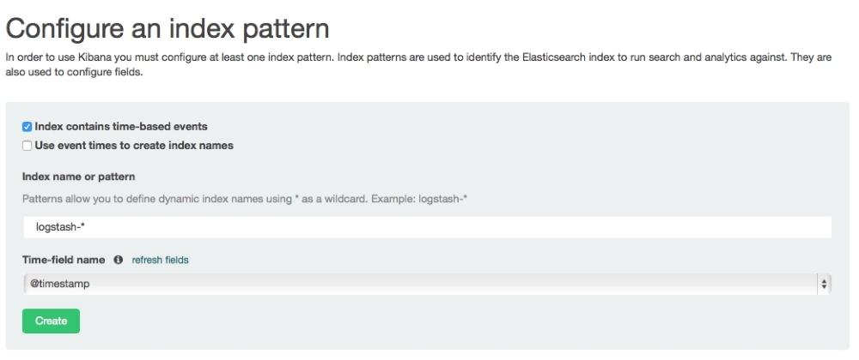
* Go to the **Discover** menu to see the logs. If everything is successful, we will see the Kibana screenshot as follows. Note that the log messages are displayed in the Kibana screen.
* Kibana provides out-of-the-box features to build summary charts and graphs using log messages:
* 